Stacks Warning
Write and or copy the code StackWarning.c and Compile the source code.
The following is the expected outcome.

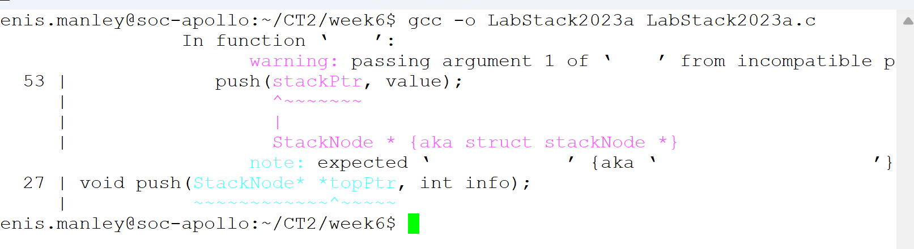
It produces one warning on line 53

A sample execution that inserts “two” nodes onto the empty stack. The screen shot shows the warning on line 53

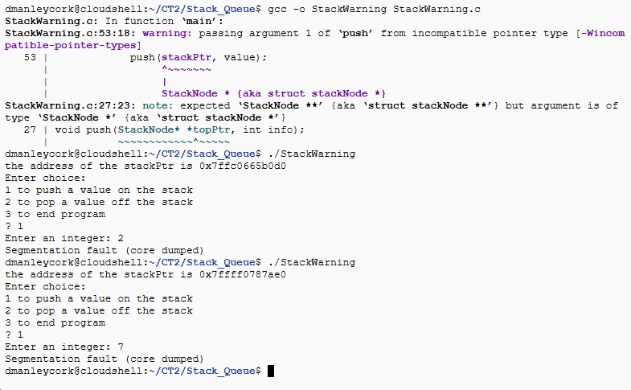

Test each menu option twice:

run the insert (push) option twice (this is illustrated in the above sample execution)
run the delete (pop) option twice
run the exit once

Fix the warning on line 53 , compile and as above re test check

run the insert (push) option twice
run the delete (pop) option twice
run the exit once

Take a screen shot of the output and
Clearly explain, using the memory addresses produced during the execution as the example, why the warning cause aberrant behaviour.

